Chapter 3

Exercise Solutions

Ex 3.1
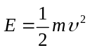
So
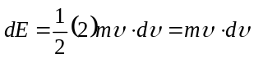
or
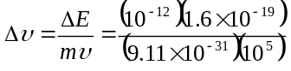
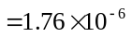m/s
or 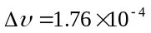cm/s
_______________________________________

Ex 3.2
At 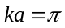, we have
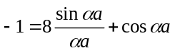
From Example 3.2, we have 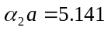,
or 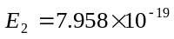J.
At 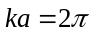, we see that 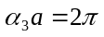 so
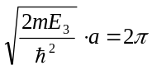
or
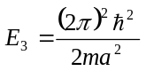
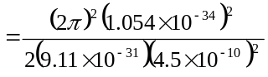
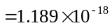J
Then
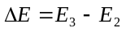
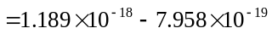
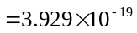J
Or
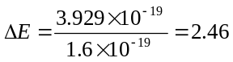eV
_______________________________________

Ex 3.3
- 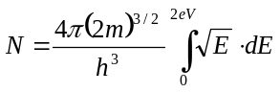
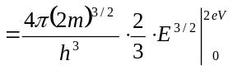
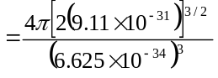
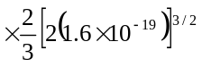
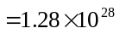 m
or
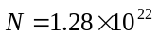cm
- 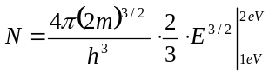
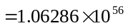
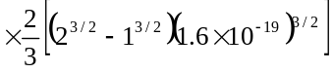
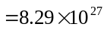 m
or
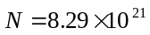cm
_______________________________________

Ex 3.4
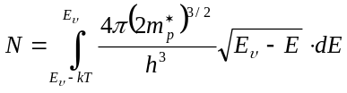
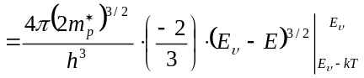

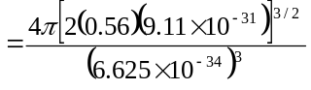
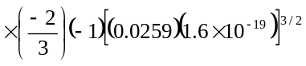
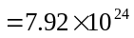m
or
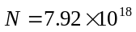cm
_______________________________________

Ex 3.5
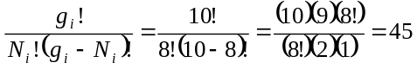
_______________________________________

Ex 3.6
- 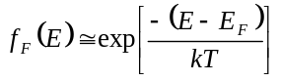
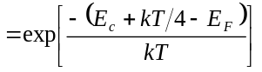
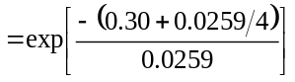
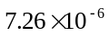
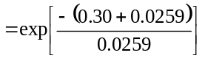
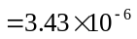
_______________________________________

Ex 3.7
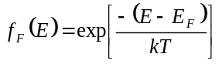
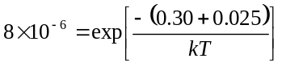
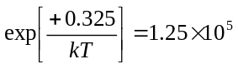
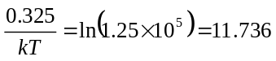
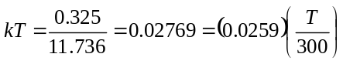
so
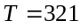K
_______________________________________

Ex 3.8
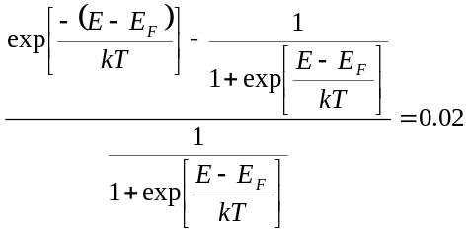
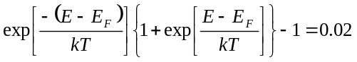

Then
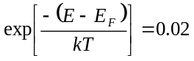
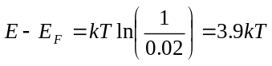
_______________________________________

Test Your Understanding Solutions

TYU 3.1
At , we see that , so
or
J
At the other point, 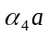 is in the range
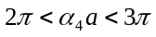. Then from
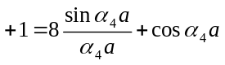
we find, by trial and error,
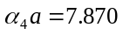. Then
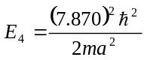
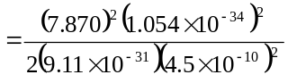
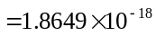J
Then
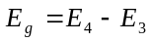
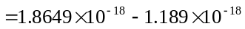
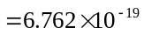J
or
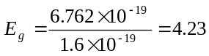eV
_______________________________________

TYU 3.2
From Example 3.2, for , 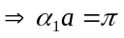
and 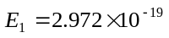J.
For 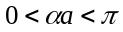 and 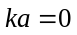, we have
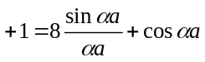
By trial and error, 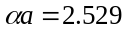rad.
Then
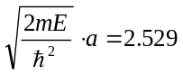
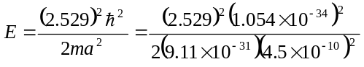
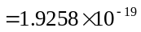J
Then
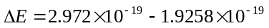
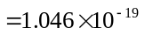J
or
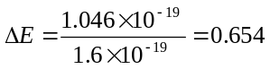eV
_______________________________________

TYU 3.3
We have 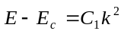
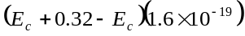
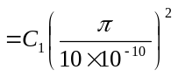
so that 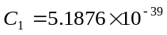
We have
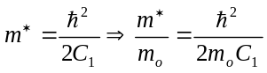
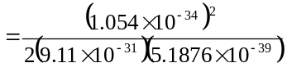
or
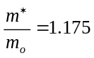
_______________________________________

TYU 3.4
We have 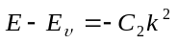
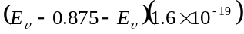
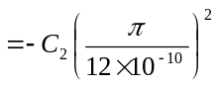
so that 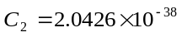

We have 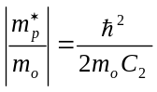
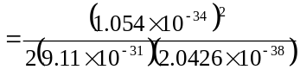
or 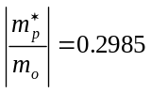
_______________________________________

TYU3.5
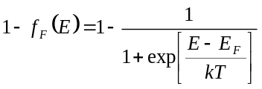
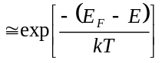
- 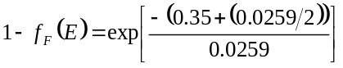
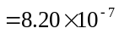
- 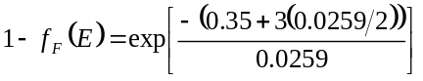
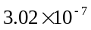
_______________________________________

TYU 3.6
We find 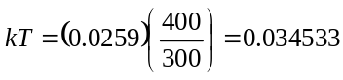eV
- 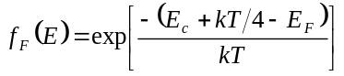
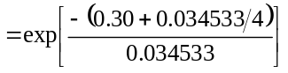
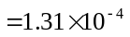
- 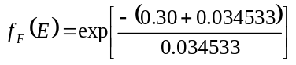
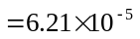
_______________________________________

TYU 3.7
We find
- 


